SNAK & YAK

Join us for Snak & Yak after the evening service on November 27th ~ bring your sandwiches ~ chips and drinks will be provided.

WE CARE ADDRESSES

Pam Casson
112 Lakeshore Drive
Stockbridge, GA 30281


You can send a card, say a prayer or make a phone call to let our members know we care.

WEDNESDAY INVITATION
November 23, 2016
Carlton Smith

It is not happy people who are thankful ~ it is thankful people who are happy.

November 13, 2016
60 a.m./89 p.m.
$1,745.00
MARK YOUR CALENDAR FOR OUR HOLIDAY PARTY


DECEMBER 3, 2016
2:30 P.M.

If you would like to pass out Bibles to our community, please join us on November 26th at 9:00 a.m. for
SERVICE SATURDAY


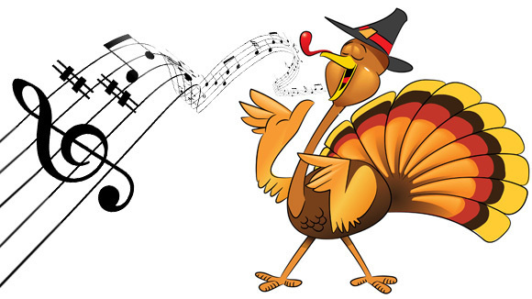
THANKSSINGING
Today at 2:00
Fayetteville Church of Chris

Prayer
Requests

Lula Childs is in Piedmont Henry ~ they are treating her thyroid.

Wyman Clark fell and broke his ankle ~ no calls, please.

Treasa Crowley, a family friend of Jeff Weathers, fell and broke her nose and ribs. Cards can be sent to:
103 Walnut Bridge Rd.,
Huntsville, AL 35806

Wyn Miller had surgery, to repair her broken shoulder, last Tuesday.

Luke Whitmire, Jerry’s great-nephew, has been diagnosed with epilepsy ~ he is dong much better.

CONTINUE TO REMEMBER:
Luella Alley, Lula Childs, Sue Collins, Willard Mann, Bill Queen, James Smith

MISSIONARIES: Robert Martin (Pacific Islands)

SHUT-INS: Gwinnell Goss; Sonny Vaughn
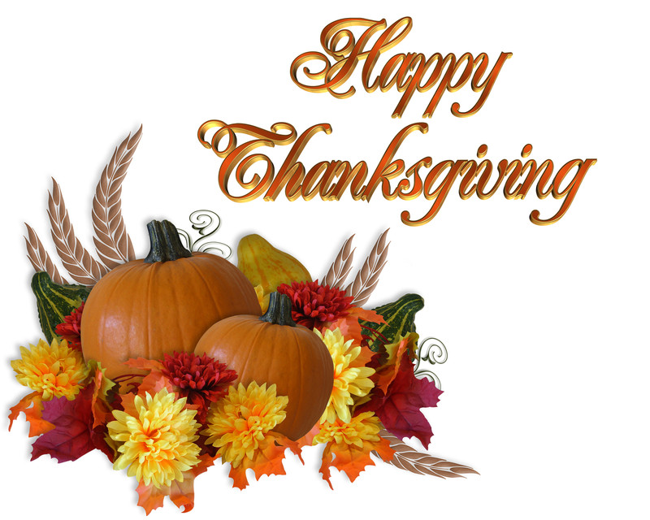

I Believe in . . .
Amazing Grace,
that there’s Power in the Blood,
that Because He Lives,
I can face tomorrow,
All because of
The Old Rugged Cross
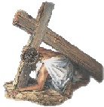

For by grace you have been saved through faith, and that not of yourselves; it is the gift of God. ~ Ephesians 2:8



OUR WEDNESDAY EVENING BIBLE STUDY WILL BE HELD ON TUESDAY, 11/22/16, DUE TO THE THANKSGIVING HOLIDAY.

Fairview Church of Christ

And you will seek Me and find Me, when you search for Me with all your heart. Jeremiah 29:13
November 20, 2016

Minister:
Jerry Whitmire
678-432-4953 Home
678-492-0383 Cell

Church Info:
1048 Swan Lake Rd.
Stockbridge, GA 30281
Phone: 770-474-7107
Fax: 770-506-0136
Email: frvwcoc@yahoo.com

Services:
Sunday
Bible Study . . . . 9:30 a.m.
Worship . . . . . 10:30 a.m.
Worship . . . . . . 6:00 p.m.
Wednesday
Bible Study . . . . 7:00 p.m.

Worship Assignments
November 27, 2016

Announcements/Opening Prayer: Jeff Weathers

Lead Singing: Darrell Cooper

Lord’s Supper:
Dennis Brown, Carlton Smith,
Allen Dailey, Jayland Fowler

Reading: Jayland Fowler

Prayer: Ben Born
Attitude

How can one develop a proper attitude toward God? First, our attitude toward God must be based on our conviction that “He is,” and that “He is a rewarder of those who diligently seek Him” (Hebrews 11:6). This kind of faith will produce a good attitude of godly fear, and “the fear of the Lord is the beginning of knowledge” (Proverbs 1:7). Second, God is absolutely holy, absolutely perfect, and absolutely wise. He is grieved by evil. He loves man and wants us to love and obey Him. All of this should motivate us to want to be true to Him all the days of our life. Our attitude toward God will then be such as expressed by the heavenly hosts: “Worthy are thou, our Lord and our God, to receive the glory and the honor and the power: for thou didst create all things, and because of thy will they were, and were created,” (Revelation 4:11).

The churches of Christ greet you.
Romans 16:16
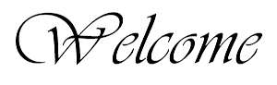

Thank You, God, For Everything
Helen Steiner Rice

Thank you, God for everything.
The big things and the small.
For “every good gift comes from God” . . .
The giver of them all.
And all too often we accept, without any thanks or praise,
The gifts God sends as blessings, each day in many ways.
And so at this Thanksgiving Time, we offer up a prayer . . .
To thank You, God, for giving us a lot more than our share.

First, thank you for the little things
That often come our way,
The things we take for granted
But don’t mention when we pray,
The unexpected courtesy, the thoughtful, kindly deed,
A hand reached out to help us in the time of sudden need.
Oh, make us more aware, dear God, of little daily graces

That come to us with “sweet surprise”
From never-dreamed-of places.

Then, thank you for the “Miracles”
We are much too blind to see,
And give us new awareness of our many gifts from Thee.
And help us to remember that the Key of Life and Living
Is to make each prayer a Prayer of Thanks
And every day Thanksgiving.

